## Prelim Pages

Version Control /Approval etc

## Introduction

This chapter presents users with an overview of the process and what data is critical to successfully achieving a positive outcome.

Data preparation has been reduced to a trivial task when the automation structure mechanism is used. It is preferred for new users to this process to use the structure mechanism until more familiarity with the process is acquired.

## Key Data Requirements

The SAP (and other ERP) systems have a minimum data requirement to ensure that a generated organisation and/or position are correctly linked into the structure. Systems of this nature require a connection or link between:

* Organisations to a parent organisation (called a belongs to relationship)
* Positions to an organisation and a supervisor (called a reports to relationship)

If this data is not applied, either the generated object is not connected to the structure and therefore lost to users; or the script will fail because we are missing a mandatory data item.

The design of the data tables and test scripts only requires two (2) key data items from the target system to begin an execution. The two items are dependent purely on the structures root node, which can only be one of: Org or Position.

Successful outcomes rely on proper use of the default data and preparation of the output to the test tool.

## Default Data Preparation

Default data sheet is set up before preparing for a new system and to help fill missing data. The level of control is considerable and its correct use will ensure a positive result across the chosen data set.

To access Default Data, click on the Tab button in the SAP ribbon, select Default Data from the listing and click OK. You may optionally check Activate Selected as shown in Figure 1 below.

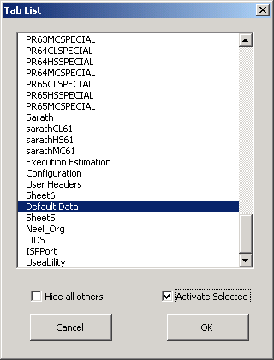

Figure

In Figure 2 below the Column Head (or Column ID as seen by the test tool) can have defaults applied when the data is initially generated and, call data can be updated or cleared by using the force column. The sample data as shown would change the values in Columns 1 and 2 to the associated Default column value.

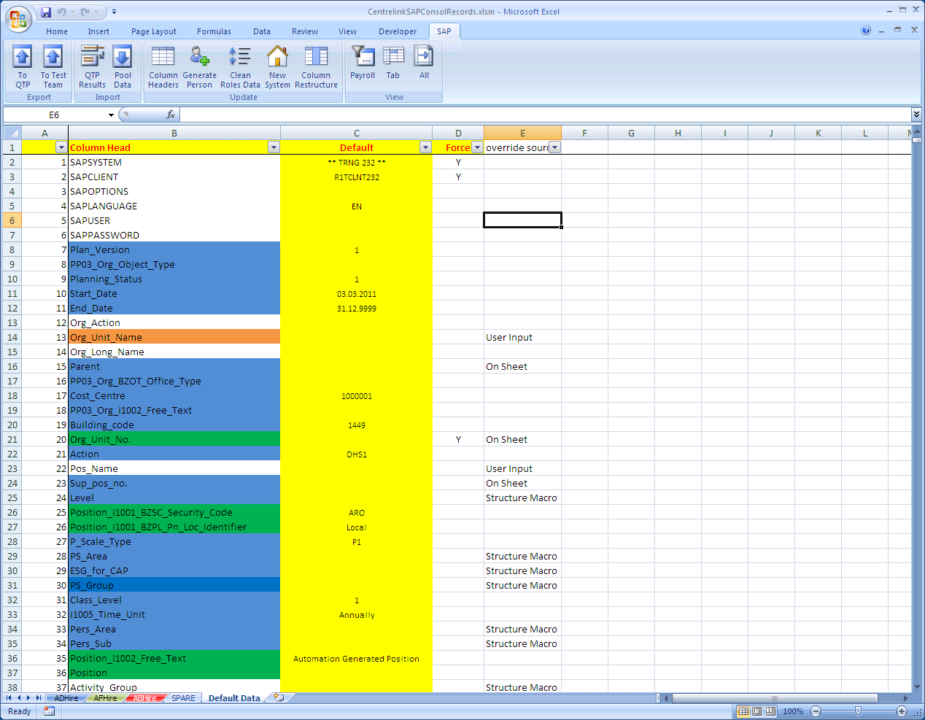

Figure - Sample Default Data

Be aware that setting force for a column with a blank default will apply the blank value to the target column. Figure 3 below shows the use of Force on a blank Default value. In this instance, the values are forced to a blank in the data set when the New System button is clicked.

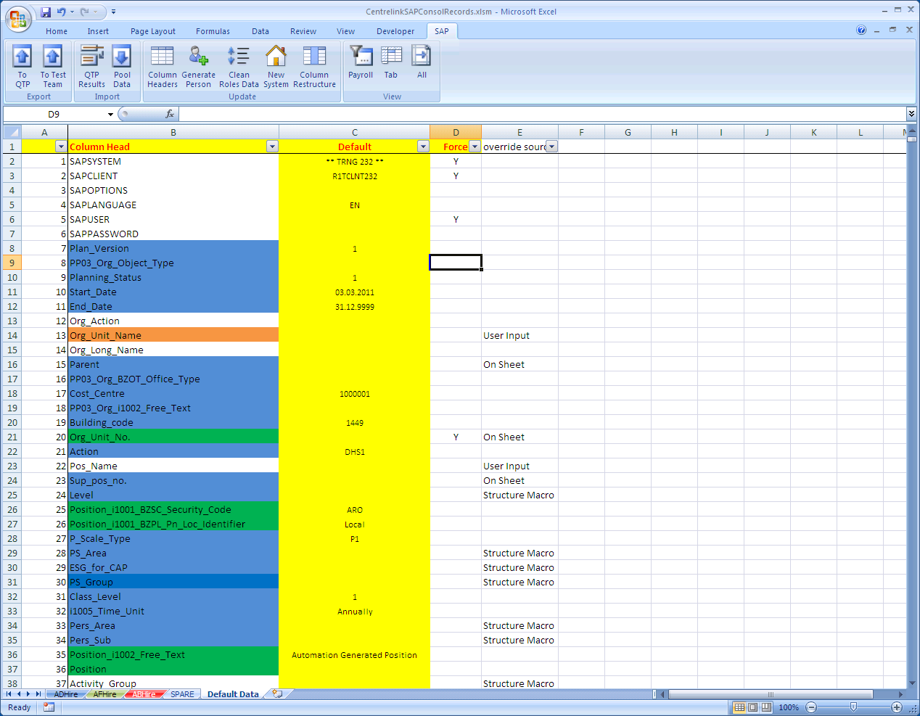

Figure - Sample Force Blank

It is not recommended that personnel details are forced to change once they are generated.

## Data Set Preparation

Ask the test team to help you with accessing the target system and finding the location(s) in the structure if you have not done this before. With additional experience a test engineer will be able to do this without external help.

* Filter the data set you want with the View Payroll button on the SAP Ribbon.
* Control the data population with the X column.
* If used before, click the X button on the ribbon.
* First data row (physical row 2) of each sheet in the data set (eg payrolls 60-69 have three sheets each).
* For both types – get the supervisor ID from the system – Apply to Sup_No.
* If there is an Org name - get the parent org id from SAP apply to Parent.
* If there is a position, get the org id to start from SAP apply to Org_Unit_Id.

You are now ready to Export the data to the test tool.

...oooOOOooo...